Activity 6-1

Question 1
Differentiate the following expressions with respect to x:
a) tan 2x | d) (5x+3)⁶ | g) cosh²x
b) log₁₀(x² – 3x -1) | e) ln cos 3x | h) sin³ 4x
c) e^{2x} sin 3x | $$f) \frac{x^{4}}{{\left(x+1\right)}^{2}}$$ | $$k) \frac{ e^{4x}\sin{x}}{2\cos{2x}}$$

Question 2

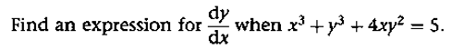
Question 3

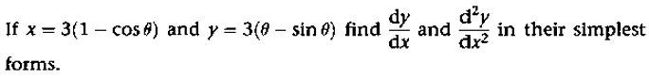
Question 4

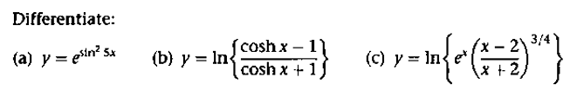
Question 5

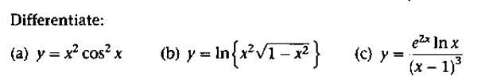
Question 6

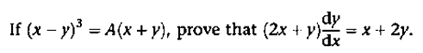
Question 7

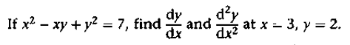
Question 8

Question 9

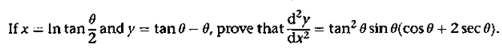
Question 10

Question 11

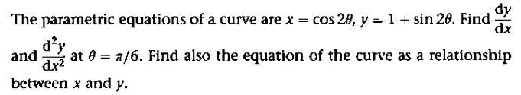
Question 12

Question 13

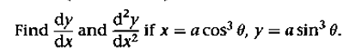
Question 14

Question 15

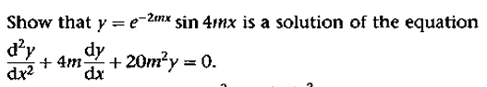
Question 16

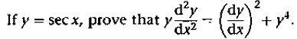
Question 17

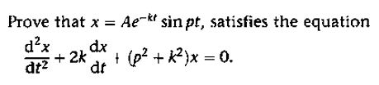
Question 18

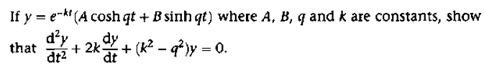
Question 19

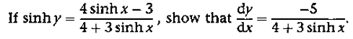
Question 20

